**St Augustine of Canterbury Catholic Primary School**

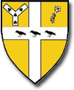**Whole School Curriculum Map for PE**

